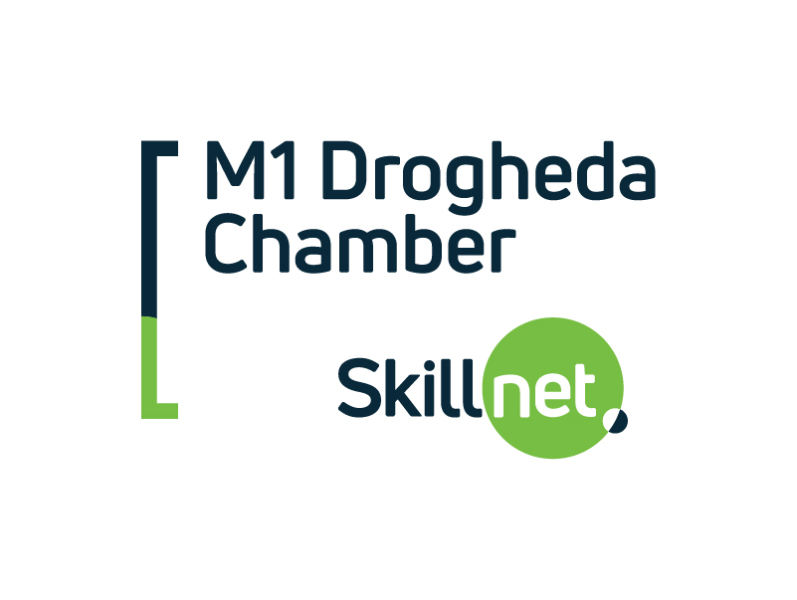
Employed Trainee Profile Form

Welcome to your Skillnet Ireland training programme. This Trainee Profile Form is used by Skillnet Ireland and M1 Drogheda Chamber Skillnet (the "Learning Network") to collect information relating to participants on training programmes partially or fully-funded by Skillnet Ireland from the National Training Fund through the Department of Education and Skills (DES). Skillnet Ireland is mandated by the DES to monitor and evaluate training programmes and to ensure that funds are being used appropriately.
Skillnet Ireland and the Learning Network will comply with all applicable Data Protection Legislation in the processing of the information and personal data provided by you in this Form.
WHAT WE USE YOUR PERSONAL DATA FOR

We use your personal data for the following purposes:

- Delivering Skillnet Ireland training programmes via the Learning Network.

- Monitoring the training programmes of the Learning Network. Skillnet Ireland is required by the DES to perform compliance reviews, evaluations of the training programmes, quality assurance and to verify attendance at training. You may be contacted either by telephone or email for these purposes.

- For the purposes of providing aggregated statistical information to the DES to help inform national policy in relation to skills.

You may be contacted by third parties, contracted by Skillnet Ireland to perform monitoring and evaluation activities for these specific purposes only.

WHAT BASIS DO WE RELY ON TO PROCESS YOUR PERSONAL DATA?

Skillnet Ireland relies on the legal basis of necessary legitimate interests to process your personal data. Further information on this can be found in the Skillnet Ireland Trainee Privacy Statement at:
https://www.skillnetireland.ie/data-protection/Skillnet-Ireland-Trainee-Privacy-Statement

Employed Trainee Profile Form

PLEASE COMPLETE (ALL FIELDS MANDATORY)
First Name: Surname:
Phone Number: Email Address:
Gender: Male Female County of Residence:
Please select your age range below:
Under 20 20-24 25-29 30-34 35-39 40-49 50-59 Over 60
Please select your highest attainment level on the National Framework of Qualifications (NFQ):
NFQ 1 Certificate  NFQ 2 Certificate  NFQ 3 Junior Certificate  NFQ 4 Leaving Certificate  NFQ 5 Leaving Certificate Honours | NFQ 6 Advanced/Higher Certificate  NFQ 7 Ordinary Bachelor Degree  NFQ 8 Honours Bachelor Degree/Higher Diploma  NFQ 9 Masters Degree/Post Graduate Diploma  NFQ 10 Doctoral Degree
Company Name:
Company Address:
What is your occupation category?
Owner Manager Managerial/Supervisor Professional
Semi Skilled Technician/Technical Skilled Manual Operative Level
The Skillnet Ireland Data Protection Officer can be contacted at dpo@skillnetireland.ie
For further information on Skillnet Ireland and our Learning Networks please visit www.skillnetireland.ie

